weights = [1.5, 0.5, 1.0]

1 run...

<tqdm.auto.tqdm object at 0x7f3a3ba572d0>

<tqdm.auto.tqdm object at 0x7f3af5ffe9d0>

training 1 epoch...

237.54372096061707 seconds used......

1 training finished! average train loss: 0.6138362892930718

evaluating...

Confusion matrix, without normalization

[[ 764 93 165]

[1369 3873 165]

[1066 208 9491]]

Normalized confusion matrix

[[0.74755382 0.09099804 0.16144814]

[0.25319031 0.71629369 0.030516 ]

[0.09902462 0.01932188 0.88165351]]

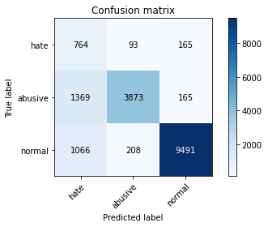

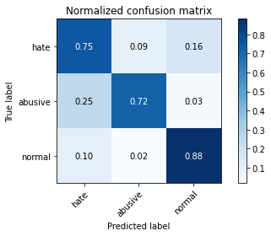

precision recall f1-score support

hate 0.24 0.75 0.36 1022

abusive 0.93 0.72 0.81 5407

normal 0.97 0.88 0.92 10765

accuracy 0.82 17194

macro avg 0.71 0.78 0.70 17194

weighted avg 0.91 0.82 0.85 17194

average eval_loss: 0.47292019198107166, accuracy: 0.8216819820867745

training 2 epoch...

237.0613396167755 seconds used......

2 training finished! average train loss: 0.432484280578708

evaluating...

Confusion matrix, without normalization

[[ 820 89 113]

[1800 3485 122]

[1818 183 8764]]

Normalized confusion matrix

[[0.80234834 0.08708415 0.11056751]

[0.33290179 0.64453486 0.02256334]

[0.16888063 0.01699954 0.81411983]]

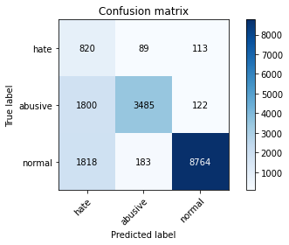

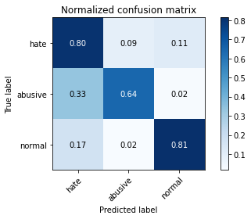

precision recall f1-score support

hate 0.18 0.80 0.30 1022

abusive 0.93 0.64 0.76 5407

normal 0.97 0.81 0.89 10765

accuracy 0.76 17194

macro avg 0.70 0.75 0.65 17194

weighted avg 0.91 0.76 0.81 17194

average eval_loss: 0.578825119882822, accuracy: 0.7600907293241829

training 3 epoch...

236.82542395591736 seconds used......

3 training finished! average train loss: 0.30914451533394527

evaluating...

Confusion matrix, without normalization

[[ 832 77 113]

[1853 3425 129]

[2021 215 8529]]

Normalized confusion matrix

[[0.81409002 0.07534247 0.11056751]

[0.3427039 0.63343814 0.02385796]

[0.18773804 0.01997213 0.79228983]]

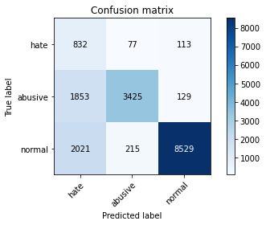

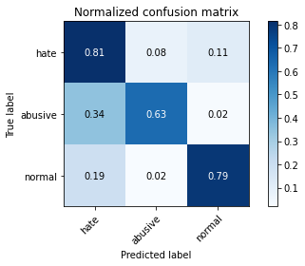

precision recall f1-score support

hate 0.18 0.81 0.29 1022

abusive 0.92 0.63 0.75 5407

normal 0.97 0.79 0.87 10765

accuracy 0.74 17194

macro avg 0.69 0.75 0.64 17194

weighted avg 0.91 0.74 0.80 17194

average eval_loss: 0.705578762518112, accuracy: 0.743631499360242

training 4 epoch...

236.81980299949646 seconds used......

4 training finished! average train loss: 0.20219344407336842

evaluating...

Confusion matrix, without normalization

[[ 762 149 111]

[1227 4050 130]

[2022 306 8437]]

Normalized confusion matrix

[[0.74559687 0.14579256 0.10861057]

[0.22692806 0.74902904 0.02404291]

[0.18783093 0.02842545 0.78374361]]

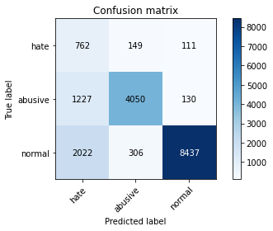

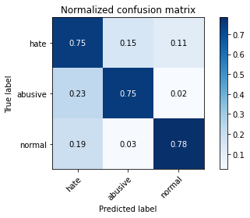

precision recall f1-score support

hate 0.19 0.75 0.30 1022

abusive 0.90 0.75 0.82 5407

normal 0.97 0.78 0.87 10765

accuracy 0.77 17194

macro avg 0.69 0.76 0.66 17194

weighted avg 0.90 0.77 0.82 17194

average eval_loss: 0.7886254975962085, accuracy: 0.7705594974991276

training 5 epoch...

237.0397138595581 seconds used......

5 training finished! average train loss: 0.13790814237538768

evaluating...

Confusion matrix, without normalization

[[ 756 121 145]

[1576 3660 171]

[1674 271 8820]]

Normalized confusion matrix

[[0.73972603 0.1183953 0.14187867]

[0.29147402 0.67690031 0.03162567]

[0.15550395 0.02517418 0.81932188]]

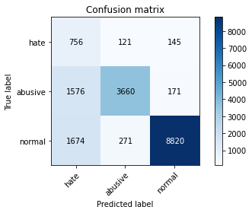

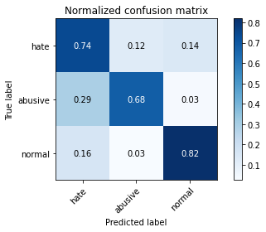

precision recall f1-score support

hate 0.19 0.74 0.30 1022

abusive 0.90 0.68 0.77 5407

normal 0.97 0.82 0.89 10765

accuracy 0.77 17194

macro avg 0.69 0.75 0.65 17194

weighted avg 0.90 0.77 0.82 17194

average eval_loss: 0.7960261308154915, accuracy: 0.7698034197976038

2 run...

training 1 epoch...

237.31152653694153 seconds used......

1 training finished! average train loss: 0.5969166130702059

evaluating...

Confusion matrix, without normalization

[[ 801 81 140]

[1608 3643 156]

[1378 197 9190]]

Normalized confusion matrix

[[0.78375734 0.07925636 0.1369863 ]

[0.29739227 0.67375624 0.02885149]

[0.12800743 0.01830005 0.85369252]]

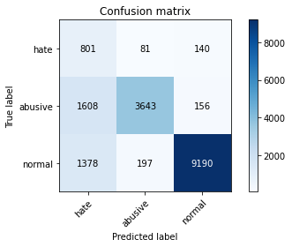

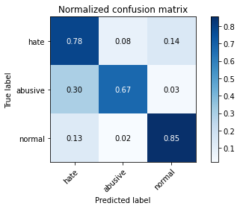

precision recall f1-score support

hate 0.21 0.78 0.33 1022

abusive 0.93 0.67 0.78 5407

normal 0.97 0.85 0.91 10765

accuracy 0.79 17194

macro avg 0.70 0.77 0.67 17194

weighted avg 0.91 0.79 0.83 17194

average eval_loss: 0.5019372807079276, accuracy: 0.7929510294288705

training 2 epoch...

237.27629780769348 seconds used......

2 training finished! average train loss: 0.43514466366434207

evaluating...

Confusion matrix, without normalization

[[ 791 103 128]

[1371 3930 106]

[1643 233 8889]]

Normalized confusion matrix

[[0.7739726 0.10078278 0.12524462]

[0.2535602 0.72683558 0.01960422]

[0.15262425 0.02164422 0.82573154]]

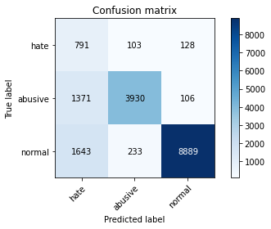

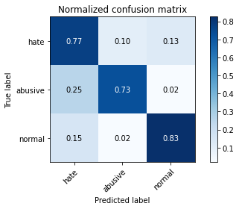

precision recall f1-score support

hate 0.21 0.77 0.33 1022

abusive 0.92 0.73 0.81 5407

normal 0.97 0.83 0.89 10765

accuracy 0.79 17194

macro avg 0.70 0.78 0.68 17194

weighted avg 0.91 0.79 0.83 17194

average eval_loss: 0.5355257144760946, accuracy: 0.7915551936722113

training 3 epoch...

237.1013216972351 seconds used......

3 training finished! average train loss: 0.31636802308917317

evaluating...

Confusion matrix, without normalization

[[ 767 101 154]

[1485 3774 148]

[1443 260 9062]]

Normalized confusion matrix

[[0.75048924 0.09882583 0.15068493]

[0.27464398 0.69798409 0.02737193]

[0.13404552 0.02415235 0.84180214]]

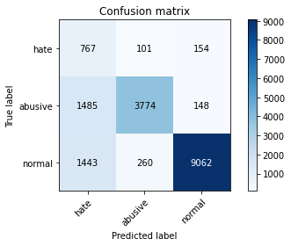

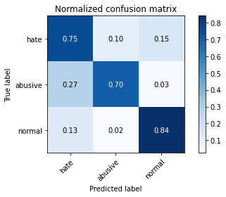

precision recall f1-score support

hate 0.21 0.75 0.33 1022

abusive 0.91 0.70 0.79 5407

normal 0.97 0.84 0.90 10765

accuracy 0.79 17194

macro avg 0.70 0.76 0.67 17194

weighted avg 0.91 0.79 0.83 17194

average eval_loss: 0.5666014811067387, accuracy: 0.7911480749098523

training 4 epoch...

237.0286042690277 seconds used......

4 training finished! average train loss: 0.2121156142145799

evaluating...

Confusion matrix, without normalization

[[ 743 125 154]

[1305 3935 167]

[1634 251 8880]]

Normalized confusion matrix

[[0.72700587 0.1223092 0.15068493]

[0.2413538 0.72776031 0.03088589]

[0.1517882 0.0233163 0.82489549]]

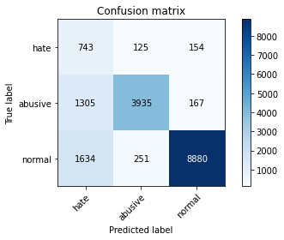

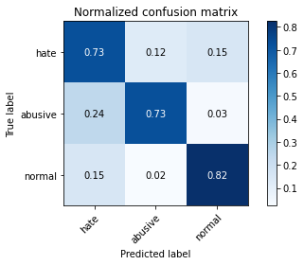

precision recall f1-score support

hate 0.20 0.73 0.32 1022

abusive 0.91 0.73 0.81 5407

normal 0.97 0.82 0.89 10765

accuracy 0.79 17194

macro avg 0.69 0.76 0.67 17194

weighted avg 0.90 0.79 0.83 17194

average eval_loss: 0.6915135176700735, accuracy: 0.7885308828661161

training 5 epoch...

236.77573919296265 seconds used......

5 training finished! average train loss: 0.14022193028555835

evaluating...

Confusion matrix, without normalization

[[ 707 139 176]

[1337 3848 222]

[1307 290 9168]]

Normalized confusion matrix

[[0.69178082 0.13600783 0.17221135]

[0.24727205 0.71167006 0.04105789]

[0.12141198 0.02693915 0.85164886]]

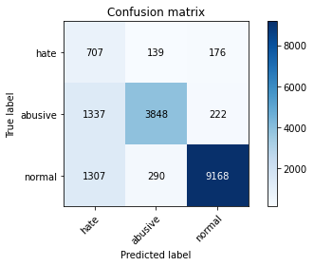

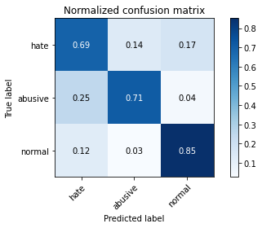

precision recall f1-score support

hate 0.21 0.69 0.32 1022

abusive 0.90 0.71 0.79 5407

normal 0.96 0.85 0.90 10765

accuracy 0.80 17194

macro avg 0.69 0.75 0.67 17194

weighted avg 0.90 0.80 0.83 17194

average eval_loss: 0.6906025344592541, accuracy: 0.7981272536931487

3 run...

training 1 epoch...

236.7958743572235 seconds used......

1 training finished! average train loss: 0.6019838322164243

evaluating...

Confusion matrix, without normalization

[[ 670 149 203]

[ 980 4212 215]

[ 708 240 9817]]

Normalized confusion matrix

[[0.6555773 0.14579256 0.19863014]

[0.18124653 0.7789902 0.03976327]

[0.06576869 0.02229447 0.91193683]]

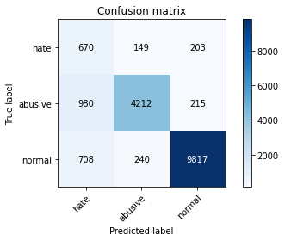

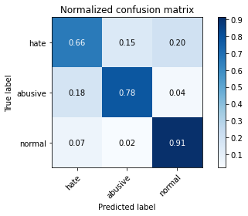

precision recall f1-score support

hate 0.28 0.66 0.40 1022

abusive 0.92 0.78 0.84 5407

normal 0.96 0.91 0.93 10765

accuracy 0.85 17194

macro avg 0.72 0.78 0.72 17194

weighted avg 0.91 0.85 0.87 17194

average eval_loss: 0.41057246877530285, accuracy: 0.854891241130627

training 2 epoch...

236.96777510643005 seconds used......

2 training finished! average train loss: 0.4367163186350472

evaluating...

Confusion matrix, without normalization

[[ 884 57 81]

[2260 3075 72]

[2636 205 7924]]

Normalized confusion matrix

[[0.86497065 0.05577299 0.07925636]

[0.4179767 0.56870723 0.01331607]

[0.24486763 0.0190432 0.73608918]]

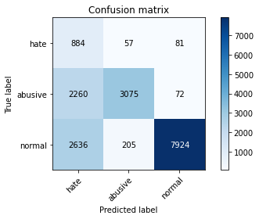

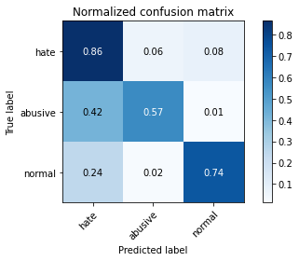

precision recall f1-score support

hate 0.15 0.86 0.26 1022

abusive 0.92 0.57 0.70 5407

normal 0.98 0.74 0.84 10765

accuracy 0.69 17194

macro avg 0.69 0.72 0.60 17194

weighted avg 0.91 0.69 0.76 17194

average eval_loss: 0.7542179282841295, accuracy: 0.6911131790159358

training 3 epoch...

236.91660070419312 seconds used......

3 training finished! average train loss: 0.31746110537049466

evaluating...

Confusion matrix, without normalization

[[ 819 72 131]

[1946 3309 152]

[1648 195 8922]]

Normalized confusion matrix

[[0.80136986 0.0704501 0.12818004]

[0.35990383 0.61198446 0.02811171]

[0.15308871 0.01811426 0.82879703]]

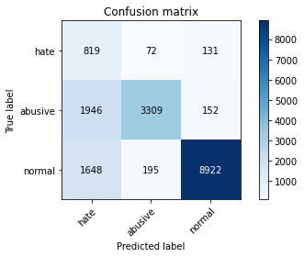

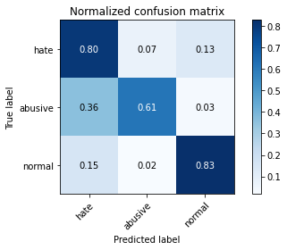

precision recall f1-score support

hate 0.19 0.80 0.30 1022

abusive 0.93 0.61 0.74 5407

normal 0.97 0.83 0.89 10765

accuracy 0.76 17194

macro avg 0.69 0.75 0.64 17194

weighted avg 0.91 0.76 0.81 17194

average eval_loss: 0.6506879112921482, accuracy: 0.7589856926834943

training 4 epoch...

236.9823818206787 seconds used......

4 training finished! average train loss: 0.2051417608587723

evaluating...

Confusion matrix, without normalization

[[ 755 130 137]

[1397 3868 142]

[1651 266 8848]]

Normalized confusion matrix

[[0.73874755 0.12720157 0.13405088]

[0.25836878 0.71536897 0.02626225]

[0.15336739 0.02470971 0.8219229 ]]

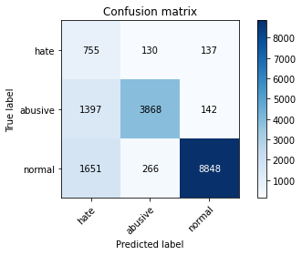

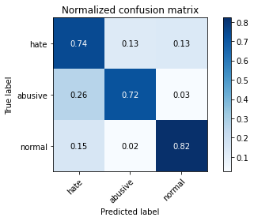

precision recall f1-score support

hate 0.20 0.74 0.31 1022

abusive 0.91 0.72 0.80 5407

normal 0.97 0.82 0.89 10765

accuracy 0.78 17194

macro avg 0.69 0.76 0.67 17194

weighted avg 0.90 0.78 0.83 17194

average eval_loss: 0.6727505120080571, accuracy: 0.7834709782482261

training 5 epoch...

236.9062225818634 seconds used......

5 training finished! average train loss: 0.14360080029748162

evaluating...

Confusion matrix, without normalization

[[ 732 138 152]

[1206 4035 166]

[1696 269 8800]]

Normalized confusion matrix

[[0.71624266 0.13502935 0.14872798]

[0.2230442 0.74625485 0.03070094]

[0.15754761 0.02498839 0.817464 ]]

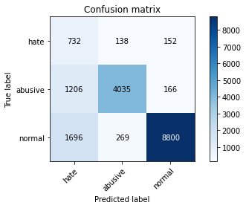

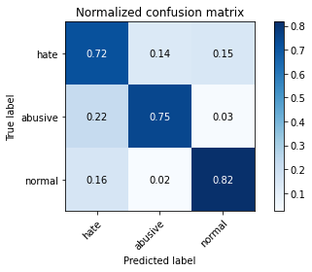

precision recall f1-score support

hate 0.20 0.72 0.31 1022

abusive 0.91 0.75 0.82 5407

normal 0.97 0.82 0.89 10765

accuracy 0.79 17194

macro avg 0.69 0.76 0.67 17194

weighted avg 0.90 0.79 0.83 17194

average eval_loss: 0.7440963602040049, accuracy: 0.7890543212748633

4 run...

training 1 epoch...

237.00068950653076 seconds used......

1 training finished! average train loss: 0.6122614671360558

evaluating...

Confusion matrix, without normalization

[[ 737 96 189]

[1313 3886 208]

[ 980 225 9560]]

Normalized confusion matrix

[[0.72113503 0.09393346 0.18493151]

[0.24283336 0.71869798 0.03846865]

[0.09103576 0.02090107 0.88806317]]

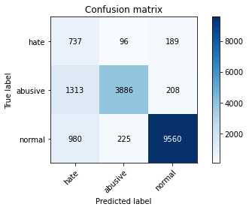

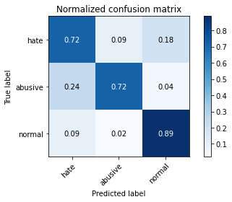

precision recall f1-score support

hate 0.24 0.72 0.36 1022

abusive 0.92 0.72 0.81 5407

normal 0.96 0.89 0.92 10765

accuracy 0.82 17194

macro avg 0.71 0.78 0.70 17194

weighted avg 0.91 0.82 0.85 17194

average eval_loss: 0.47458016071901765, accuracy: 0.824880772362452

training 2 epoch...

236.7628951072693 seconds used......

2 training finished! average train loss: 0.4442650996333589

evaluating...

Confusion matrix, without normalization

[[ 876 50 96]

[2250 3062 95]

[2289 197 8279]]

Normalized confusion matrix

[[0.85714286 0.04892368 0.09393346]

[0.41612724 0.56630294 0.01756982]

[0.21263353 0.01830005 0.76906642]]

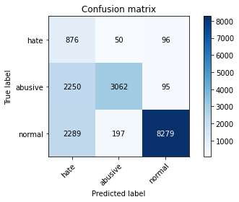

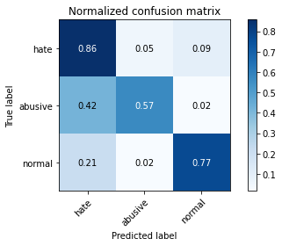

precision recall f1-score support

hate 0.16 0.86 0.27 1022

abusive 0.93 0.57 0.70 5407

normal 0.98 0.77 0.86 10765

accuracy 0.71 17194

macro avg 0.69 0.73 0.61 17194

weighted avg 0.91 0.71 0.78 17194

average eval_loss: 0.6581643038191075, accuracy: 0.7105385599627777

training 3 epoch...

237.22725534439087 seconds used......

3 training finished! average train loss: 0.3175161553054846

evaluating...

Confusion matrix, without normalization

[[ 760 124 138]

[1307 3980 120]

[1479 337 8949]]

Normalized confusion matrix

[[0.74363992 0.12133072 0.13502935]

[0.24172369 0.73608286 0.02219345]

[0.13738969 0.03130516 0.83130516]]

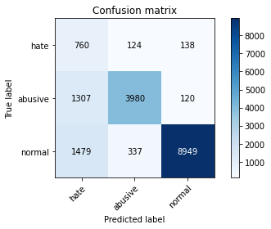

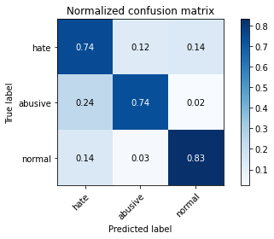

precision recall f1-score support

hate 0.21 0.74 0.33 1022

abusive 0.90 0.74 0.81 5407

normal 0.97 0.83 0.90 10765

accuracy 0.80 17194

macro avg 0.69 0.77 0.68 17194

weighted avg 0.90 0.80 0.84 17194

average eval_loss: 0.5817853300897188, accuracy: 0.7961498197045481

training 4 epoch...

237.09259581565857 seconds used......

4 training finished! average train loss: 0.21068328355163604

evaluating...

Confusion matrix, without normalization

[[ 782 125 115]

[1414 3867 126]

[2092 290 8383]]

Normalized confusion matrix

[[0.76516634 0.1223092 0.11252446]

[0.26151285 0.71518402 0.02330313]

[0.19433349 0.02693915 0.77872736]]

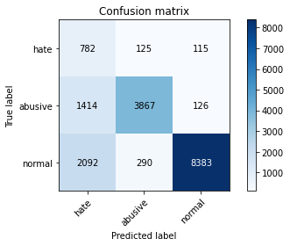

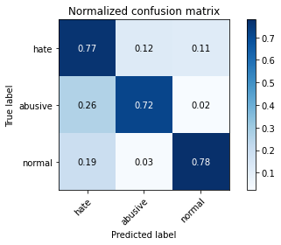

precision recall f1-score support

hate 0.18 0.77 0.29 1022

abusive 0.90 0.72 0.80 5407

normal 0.97 0.78 0.86 10765

accuracy 0.76 17194

macro avg 0.69 0.75 0.65 17194

weighted avg 0.90 0.76 0.81 17194

average eval_loss: 0.8117826664733678, accuracy: 0.7579388158659998

training 5 epoch...

237.22952556610107 seconds used......

5 training finished! average train loss: 0.14672825107893342

evaluating...

Confusion matrix, without normalization

[[ 786 108 128]

[1679 3539 189]

[2112 254 8399]]

Normalized confusion matrix

[[0.76908023 0.10567515 0.12524462]

[0.3105234 0.65452192 0.03495469]

[0.19619136 0.02359498 0.78021366]]

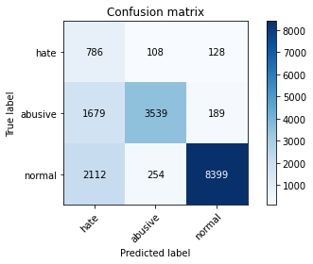

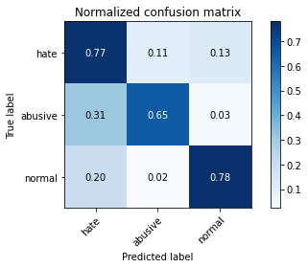

precision recall f1-score support

hate 0.17 0.77 0.28 1022

abusive 0.91 0.65 0.76 5407

normal 0.96 0.78 0.86 10765

accuracy 0.74 17194

macro avg 0.68 0.73 0.63 17194

weighted avg 0.90 0.74 0.80 17194

average eval_loss: 0.9207054021053536, accuracy: 0.7400255903222054

5 run...

training 1 epoch...

237.04536938667297 seconds used......

1 training finished! average train loss: 0.6170923494929385

evaluating...

Confusion matrix, without normalization

[[ 731 108 183]

[1345 3871 191]

[ 929 219 9617]]

Normalized confusion matrix

[[0.71526419 0.10567515 0.17906067]

[0.24875162 0.7159238 0.03532458]

[0.08629819 0.02034371 0.8933581 ]]

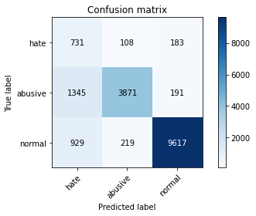

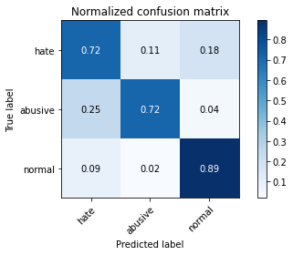

precision recall f1-score support

hate 0.24 0.72 0.36 1022

abusive 0.92 0.72 0.81 5407

normal 0.96 0.89 0.93 10765

accuracy 0.83 17194

macro avg 0.71 0.77 0.70 17194

weighted avg 0.91 0.83 0.86 17194

average eval_loss: 0.4352889718011368, accuracy: 0.8269745259974409

training 2 epoch...

237.44098043441772 seconds used......

2 training finished! average train loss: 0.4438617374941404

evaluating...

Confusion matrix, without normalization

[[ 741 124 157]

[1095 4131 181]

[1167 244 9354]]

Normalized confusion matrix

[[0.72504892 0.12133072 0.15362035]

[0.20251526 0.76400962 0.03347512]

[0.10840687 0.02266605 0.86892708]]

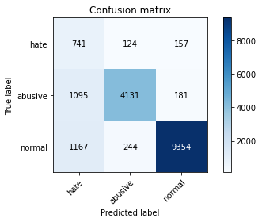

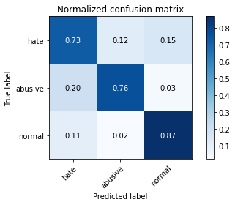

precision recall f1-score support

hate 0.25 0.73 0.37 1022

abusive 0.92 0.76 0.83 5407

normal 0.97 0.87 0.91 10765

accuracy 0.83 17194

macro avg 0.71 0.79 0.71 17194

weighted avg 0.91 0.83 0.86 17194

average eval_loss: 0.45723507434649524, accuracy: 0.8273816447597999

training 3 epoch...

237.3869616985321 seconds used......

3 training finished! average train loss: 0.32149953231989126

evaluating...

Confusion matrix, without normalization

[[ 741 130 151]

[1284 3943 180]

[1339 238 9188]]

Normalized confusion matrix

[[0.72504892 0.12720157 0.14774951]

[0.23746995 0.72923987 0.03329018]

[0.12438458 0.02210869 0.85350673]]

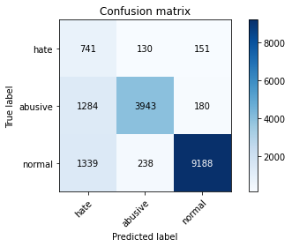

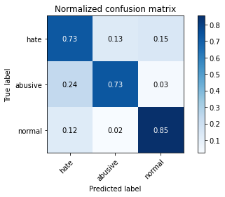

precision recall f1-score support

hate 0.22 0.73 0.34 1022

abusive 0.91 0.73 0.81 5407

normal 0.97 0.85 0.91 10765

accuracy 0.81 17194

macro avg 0.70 0.77 0.69 17194

weighted avg 0.91 0.81 0.84 17194

average eval_loss: 0.5193417187303652, accuracy: 0.8067930673490753

training 4 epoch...

237.40989422798157 seconds used......

4 training finished! average train loss: 0.20387132645376516

evaluating...

Confusion matrix, without normalization

[[ 682 162 178]

[1059 4092 256]

[1207 268 9290]]

Normalized confusion matrix

[[0.66731898 0.15851272 0.1741683 ]

[0.19585722 0.75679674 0.04734603]

[0.11212262 0.02489549 0.86298189]]

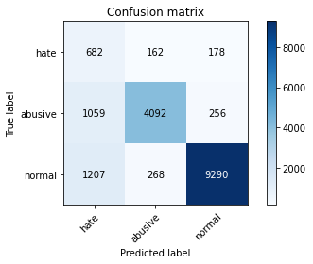

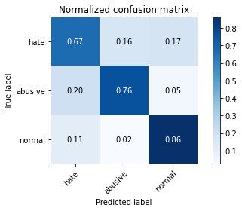

precision recall f1-score support

hate 0.23 0.67 0.34 1022

abusive 0.90 0.76 0.82 5407

normal 0.96 0.86 0.91 10765

accuracy 0.82 17194

macro avg 0.70 0.76 0.69 17194

weighted avg 0.90 0.82 0.85 17194

average eval_loss: 0.6028839352020864, accuracy: 0.8179597534023496

training 5 epoch...

237.4894278049469 seconds used......

5 training finished! average train loss: 0.14244082454238802

evaluating...

Confusion matrix, without normalization

[[ 744 155 123]

[1278 3975 154]

[1919 289 8557]]

Normalized confusion matrix

[[0.72798434 0.15166341 0.12035225]

[0.23636027 0.73515813 0.0284816 ]

[0.17826289 0.02684626 0.79489085]]

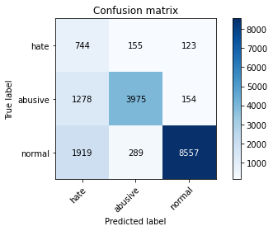

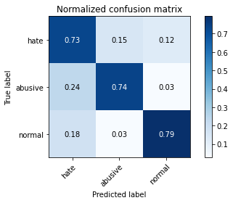

precision recall f1-score support

hate 0.19 0.73 0.30 1022

abusive 0.90 0.74 0.81 5407

normal 0.97 0.79 0.87 10765

accuracy 0.77 17194

macro avg 0.69 0.75 0.66 17194

weighted avg 0.90 0.77 0.82 17194

average eval_loss: 0.9045464357296221, accuracy: 0.7721298127253693